**Amazon EC2**

Amazon Elastic Compute Cloud (Amazon EC2) provides scalable computing capacity in the Amazon Web Services (AWS) cloud. This deprives the need of the hardware component for a system and so it helps to avoid many difficulties happens using the hardware. Also it is more efficient way and less cost consuming. You can use Amazon EC2 to launch as many or as few virtual servers as you need, configure security and networking, and manage storage.

**Features of Amazon EC2**

* Virtual computing environments.
* Various configurations of CPU, memory, storage, and networking capacity for your instances.
* Secure login information for your instances using key pairs.
* Storage volumes for temporary data that's deleted when you stop or terminate your instance.
* Persistent storage volumes for your data using Amazon Elastic Block Store.
* Multiple physical locations for your resources, such as instances and Amazon EBS volumes.
* A firewall that enables you to specify the protocols, ports, and source IP ranges that can reach your instances using security groups.
* Static IP addresses for dynamic cloud computing.
* Virtual networks you can create that are logically isolated from the rest of the AWS cloud, and that you can optionally connect to your own network.

**Amazon EC2 Windows Instances**

* Launch an instance

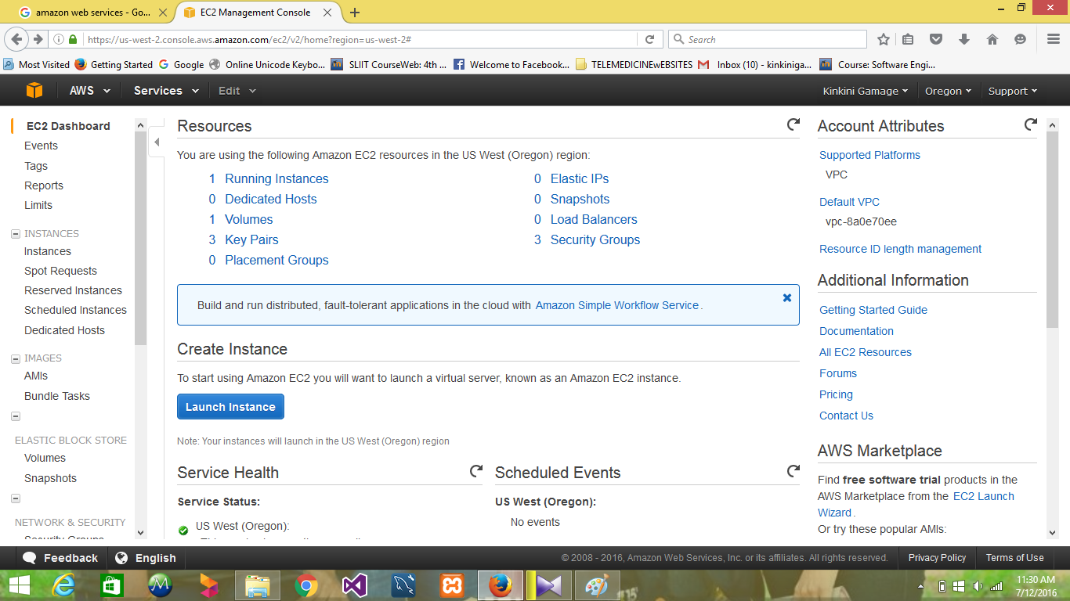

* 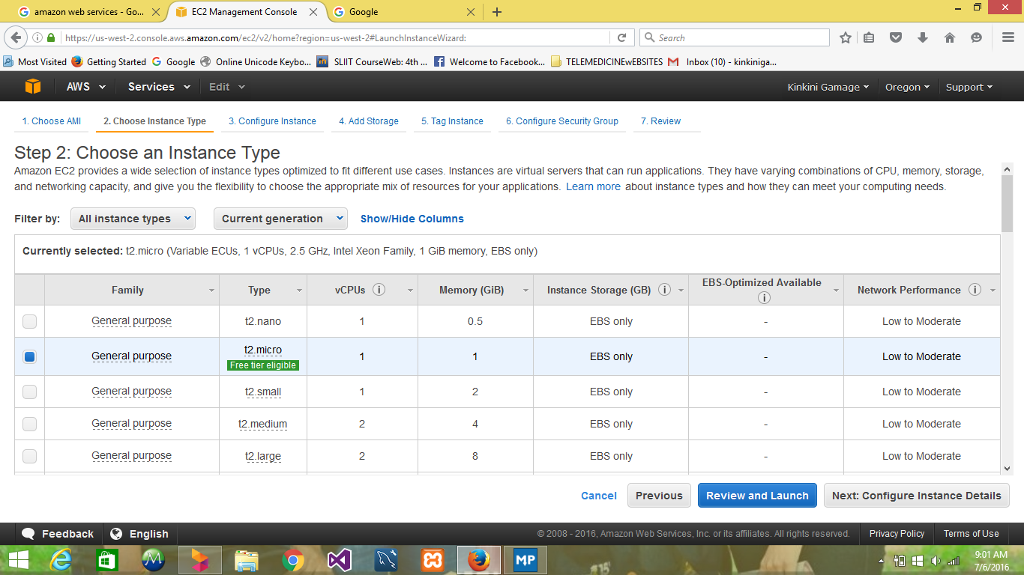Choose an Interface Type.
* Review launch Instance

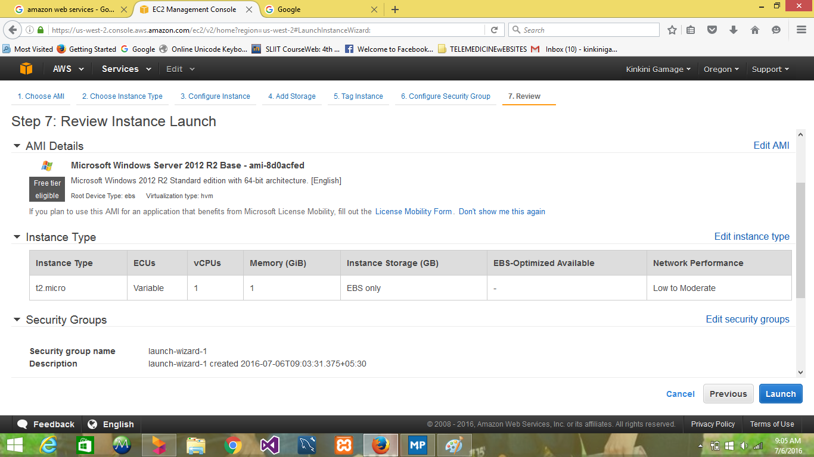

* 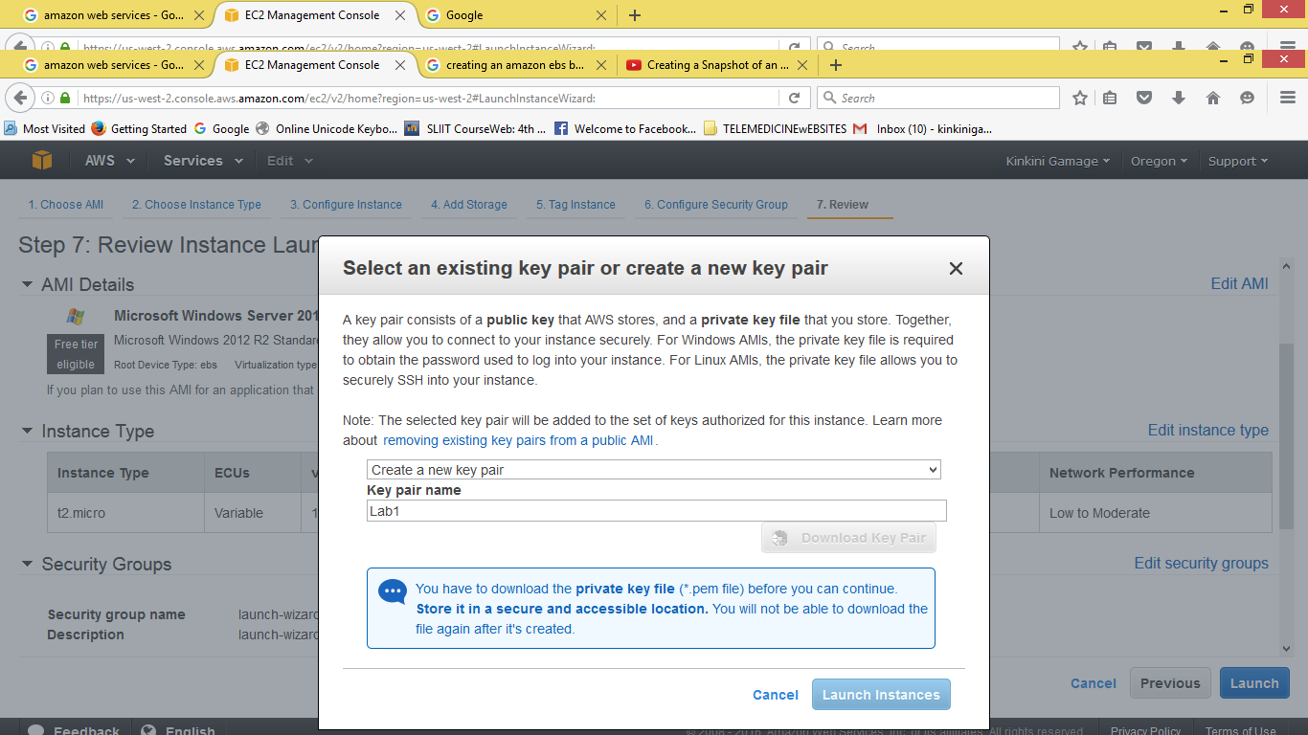Get a key pair for security issues. This is the only chance for you to save the private key file, so be sure to download it. Save the private key file in a safe place. You'll need to provide the name of your key pair when you launch an instance and the corresponding private key each time you connect to the instance.

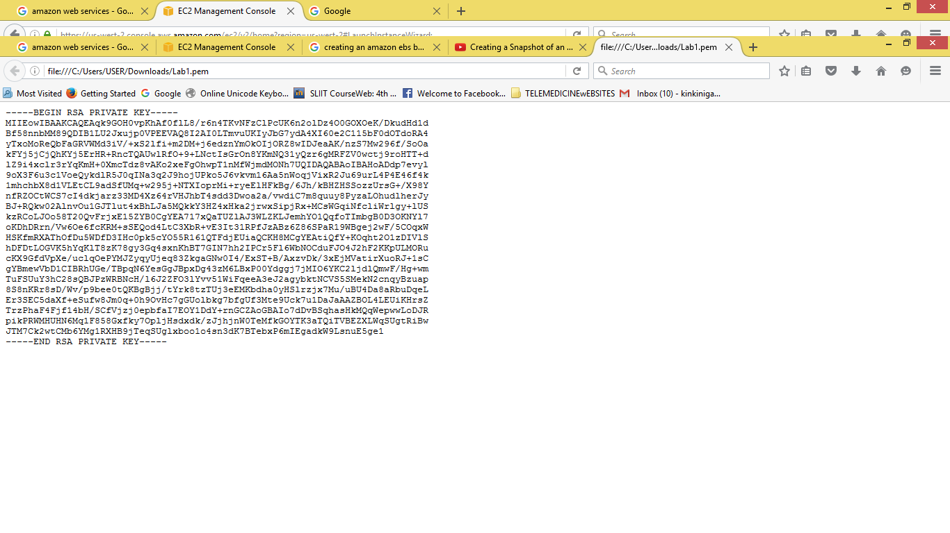• Security key pair

* A confirmation page lets you know that your instance is launching. Choose View Instances to close the confirmation page and return to the console.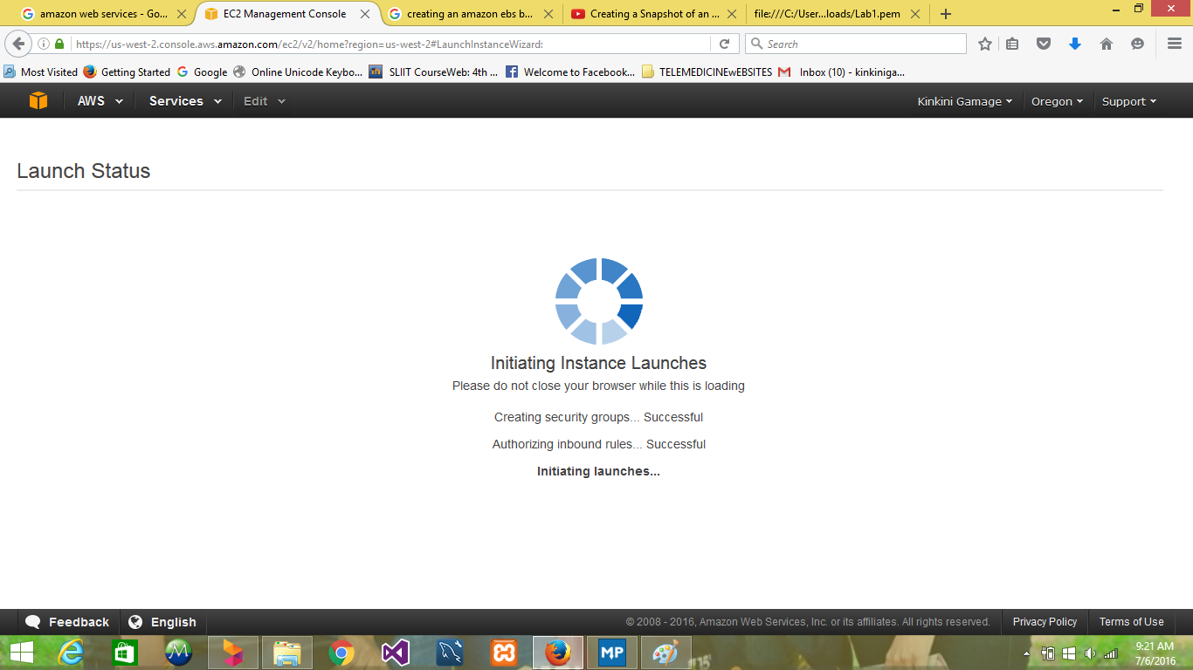
* 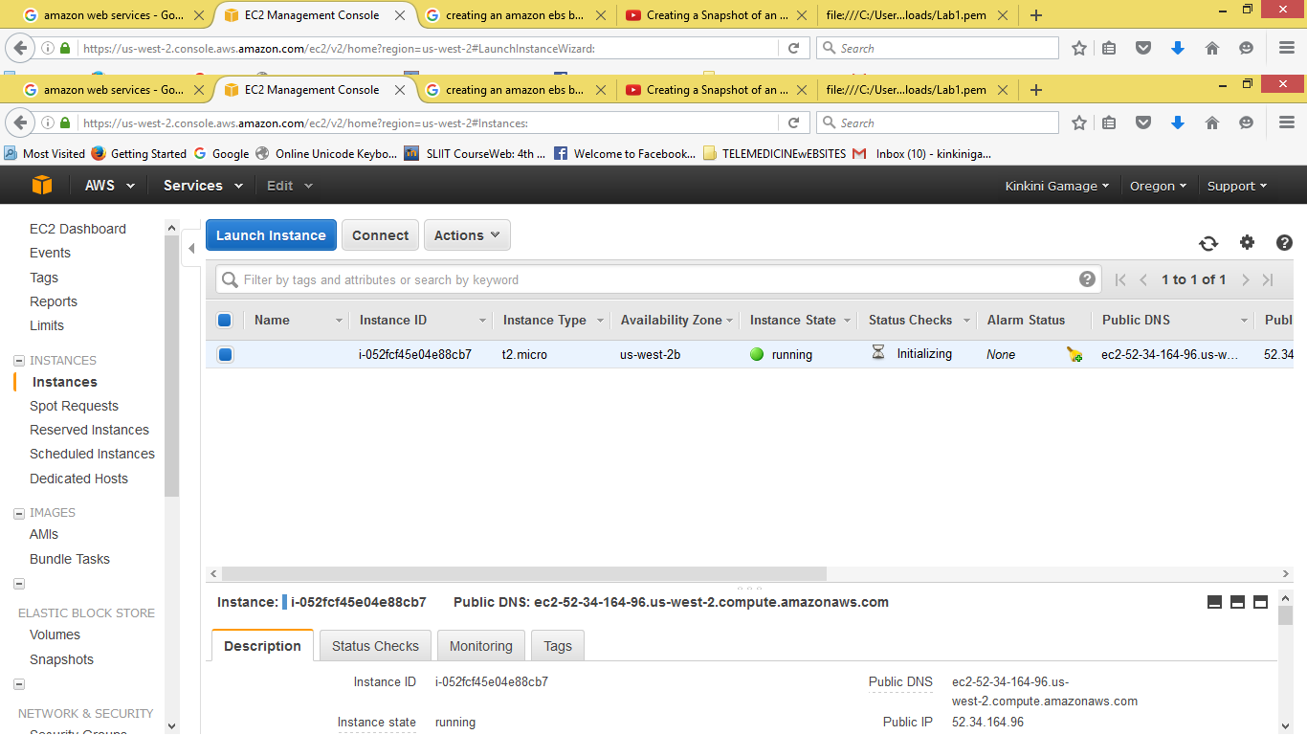On the Instances screen, you can view the status of the launch. It takes a short time for an instance to launch. When you launch an instance, its initial state is pending. After the instance starts, its state changes to running and it receives a public DNS name
* 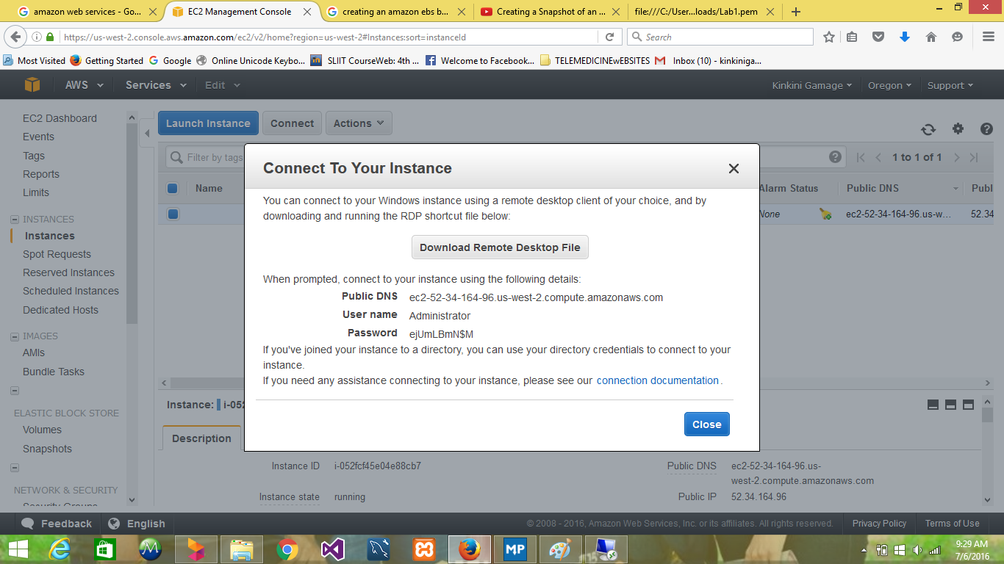To connect to a Windows instance, you must retrieve the initial administrator password and then specify this password when you connect to your instance using Remote Desktop.
* 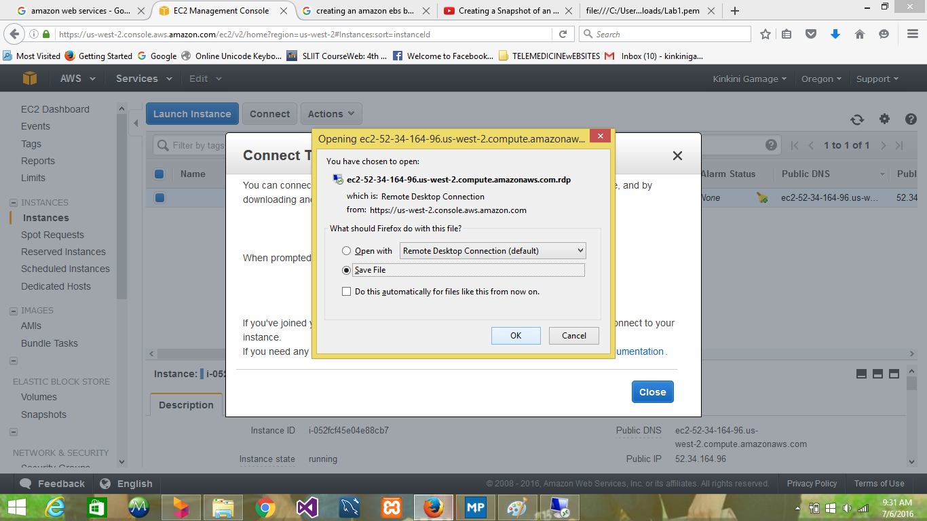Download remote desktop file and connect to your instance
* 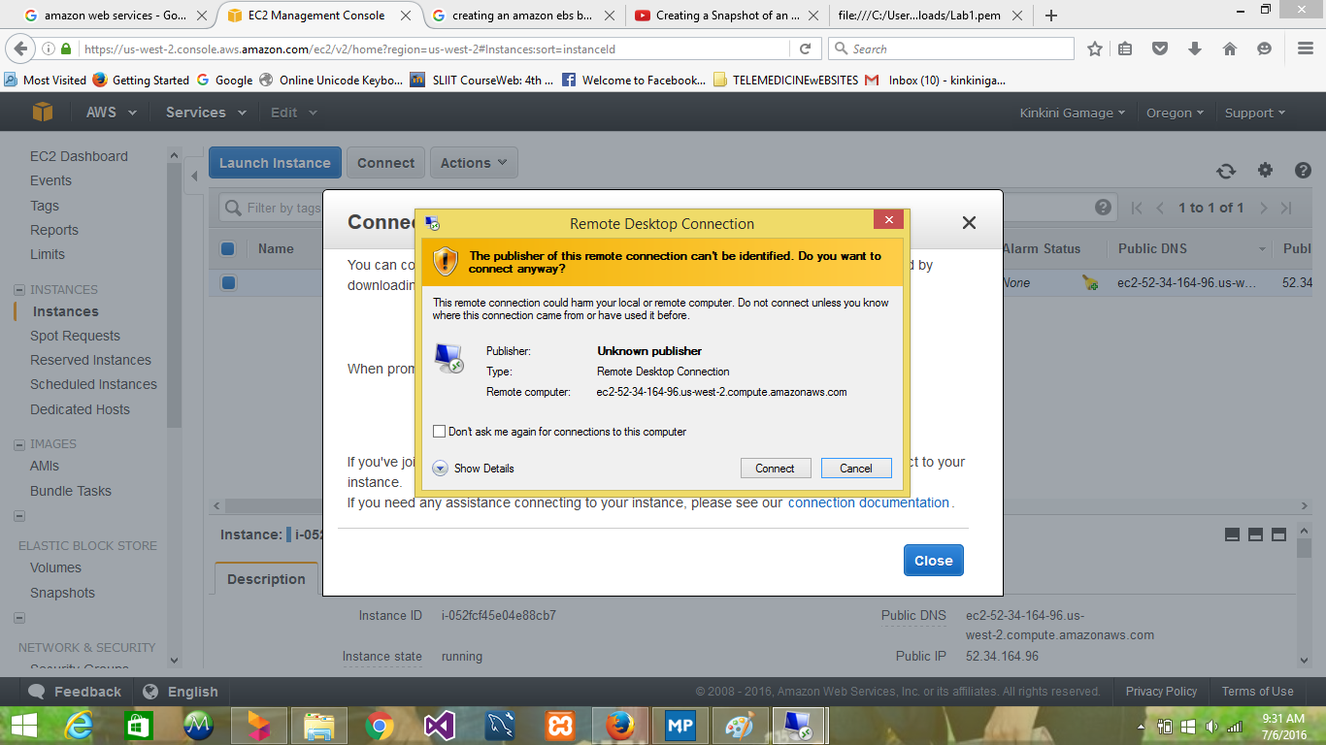Got a warning that the publisher of the remote connection is unknown. Because I am using Remote Desktop Connection from a Windows PC, I choose Connect to connect to your instance.
* 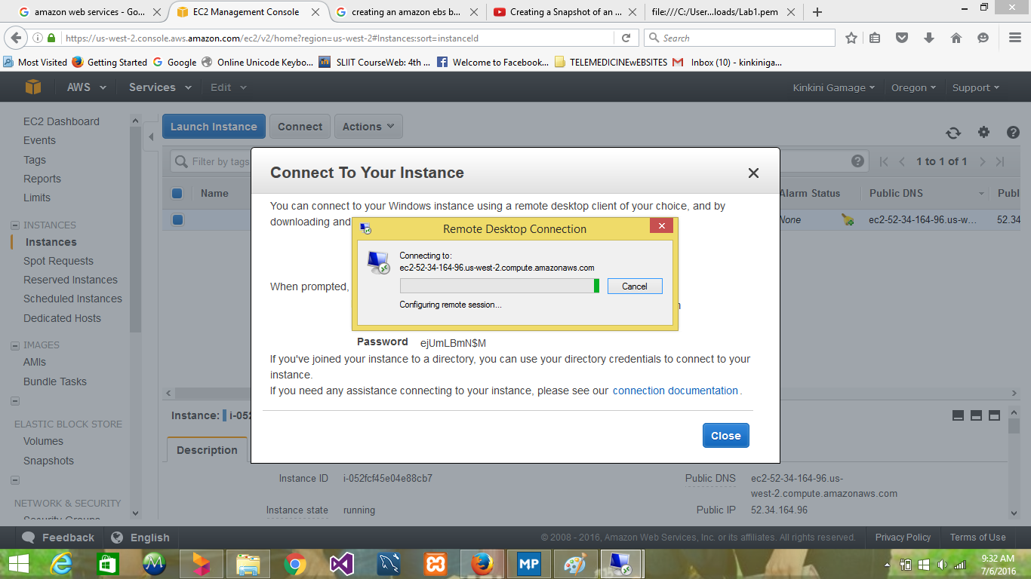Connecting to the remote desktop
* 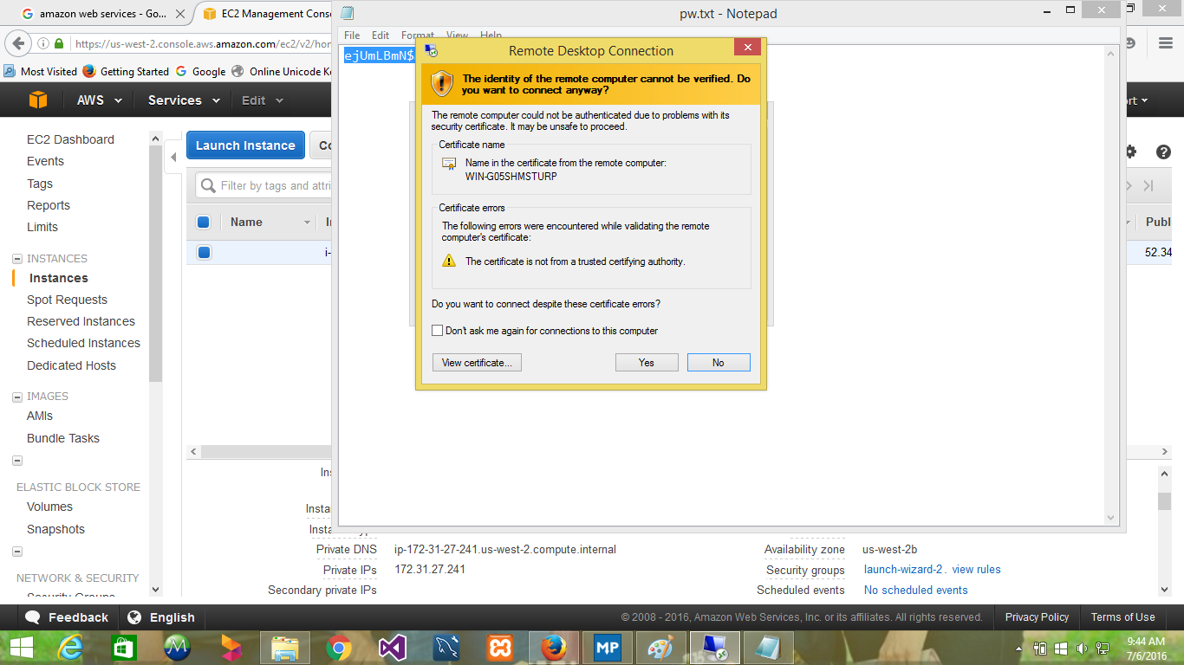Due to the nature of self-signed certificates, you may get a warning that the security certificate could not be authenticated. Use the following steps to verify the identity of the remote computer, or simply choose Yes or Continue to continue if you trust the certificate.
* 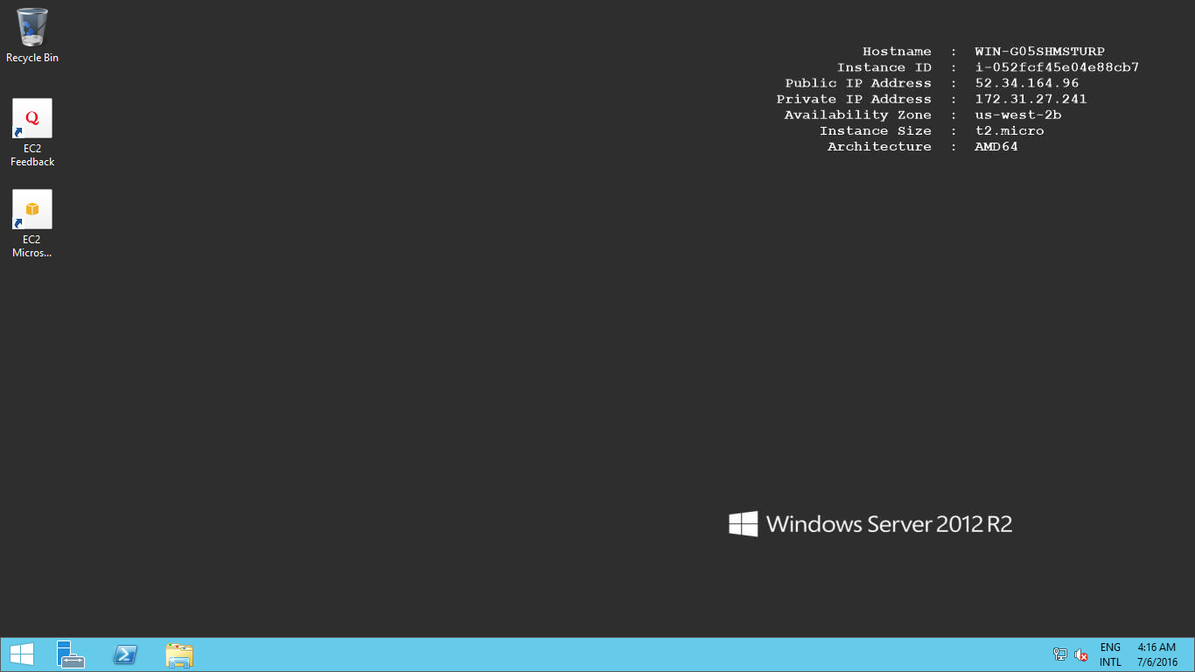Connected Windows Instance**Linux Instance**
* Launch a Linux instance using the AWS Management Console.

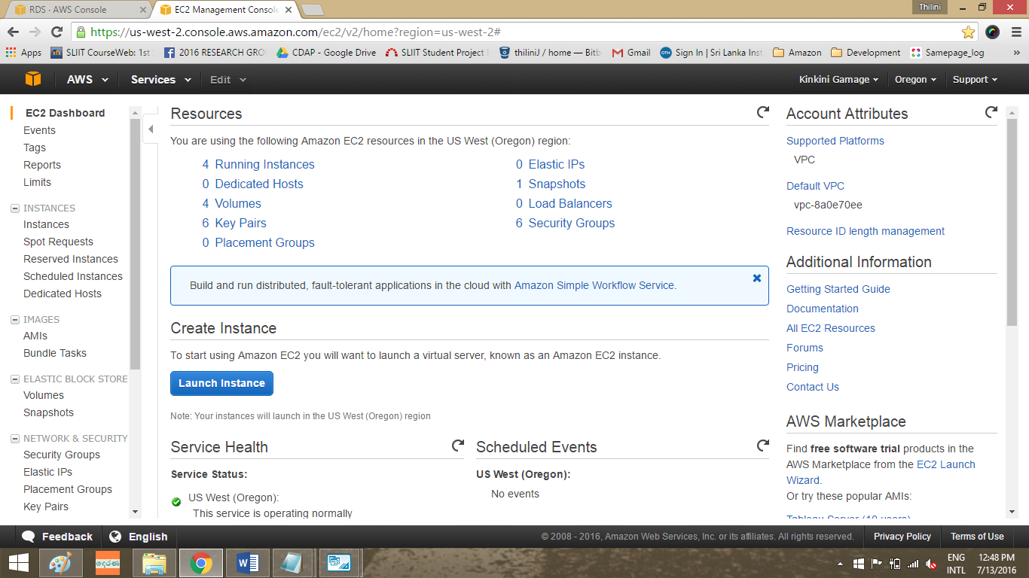

* 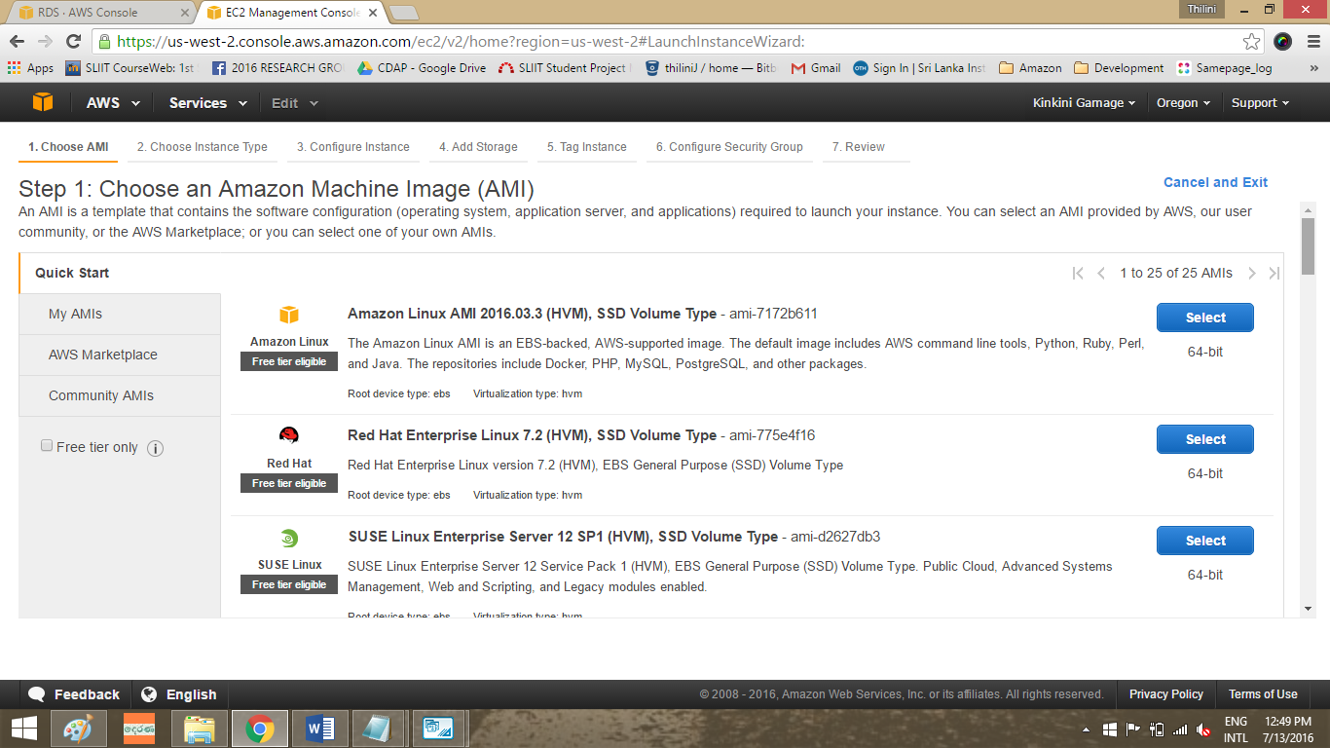Choose an Amazon machine image. That that serve as templates for the instance.
* 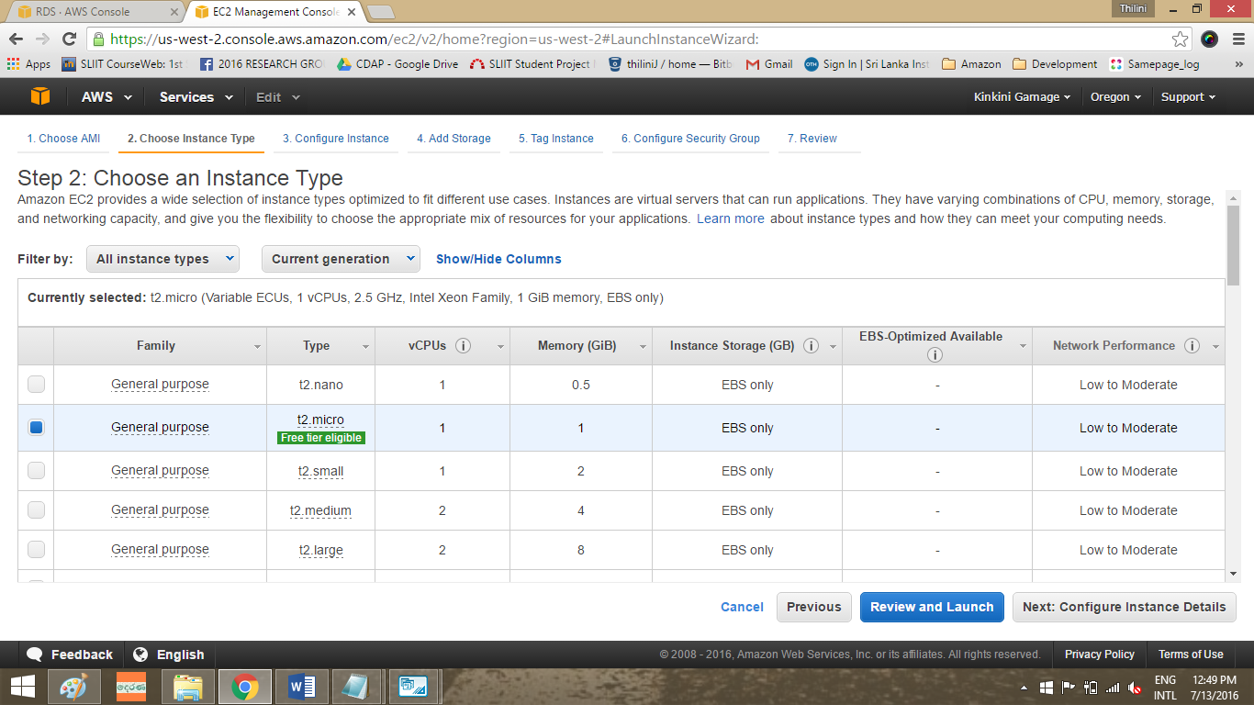This is to choose an Instance Type which allows you to select the hardware configuration of your instance. This instance type is eligible for the free tier.
* Configure instance details.

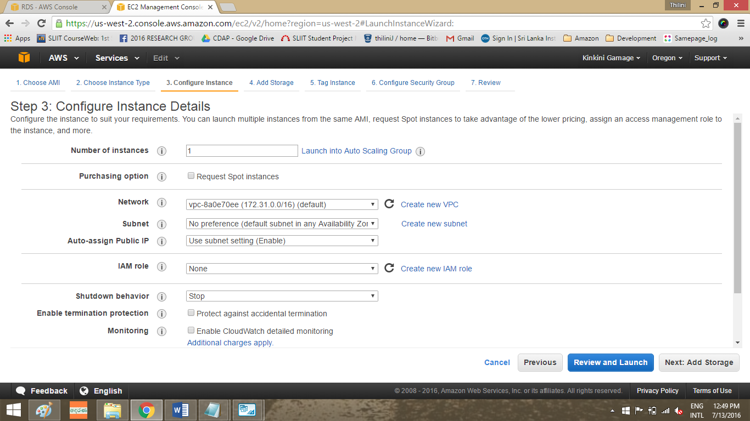

* 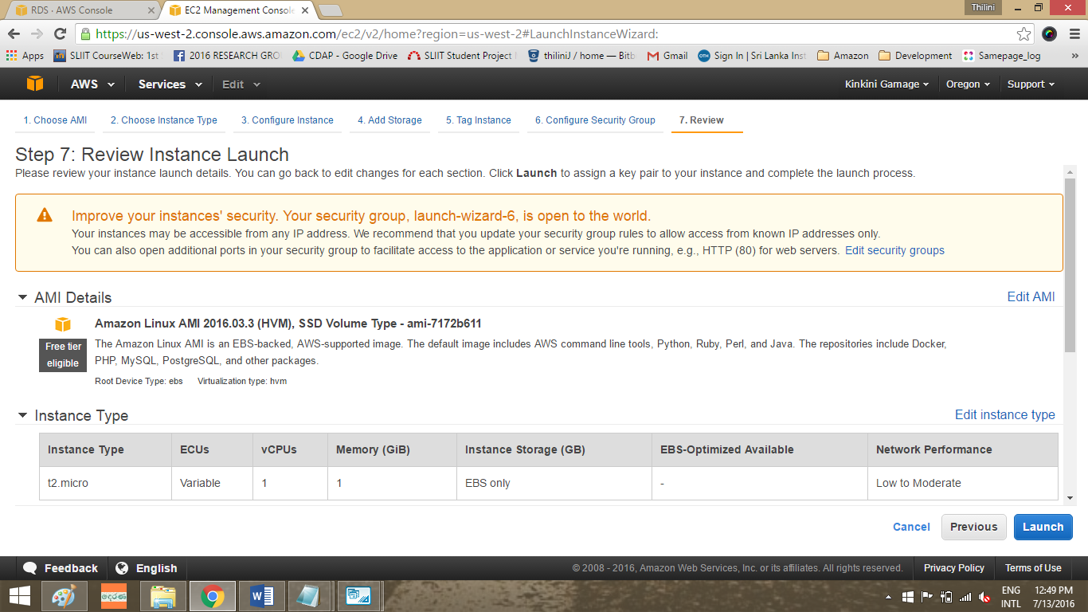Review and Launch to let the wizard complete the other configuration settings for the instance is going to be craeate.
* 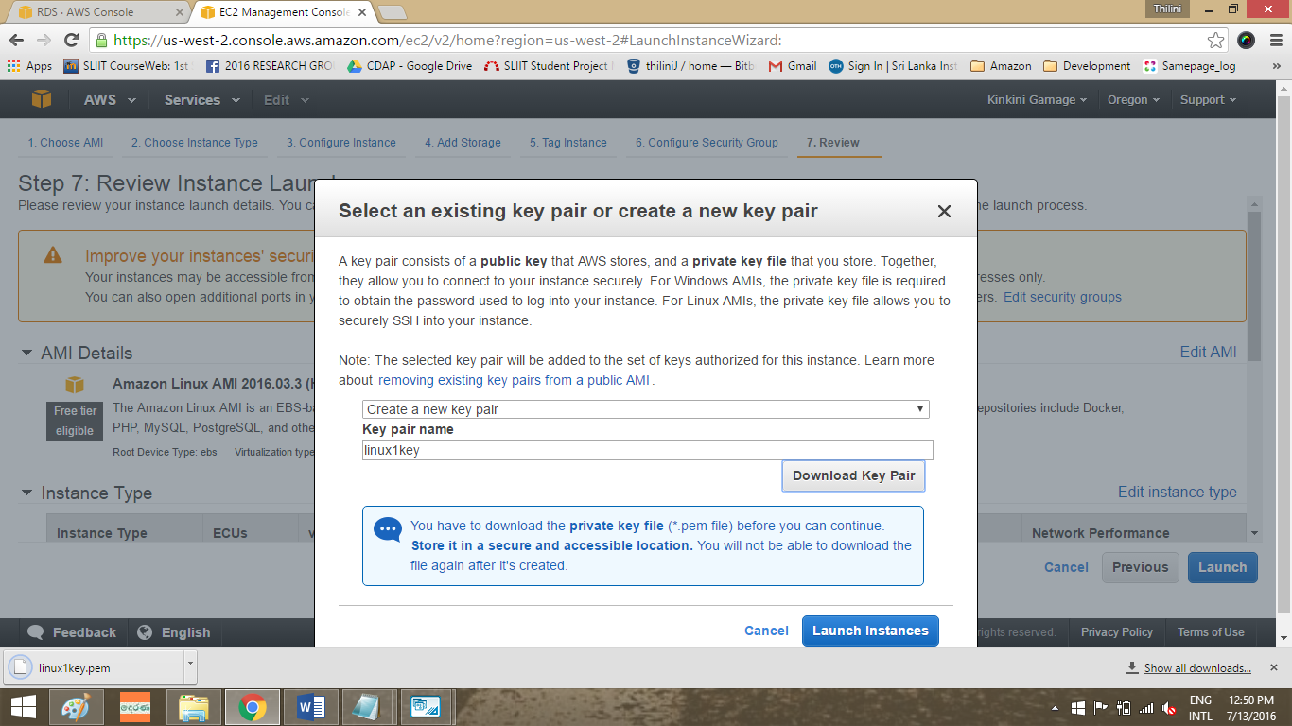To get a security key pair. This is the only chance for you to save the private key file, so be sure to download it. Save the private key file in a safe place. You'll need to provide the name of your key pair when you launch an instance and the corresponding private key each time you connect to the instance.
* 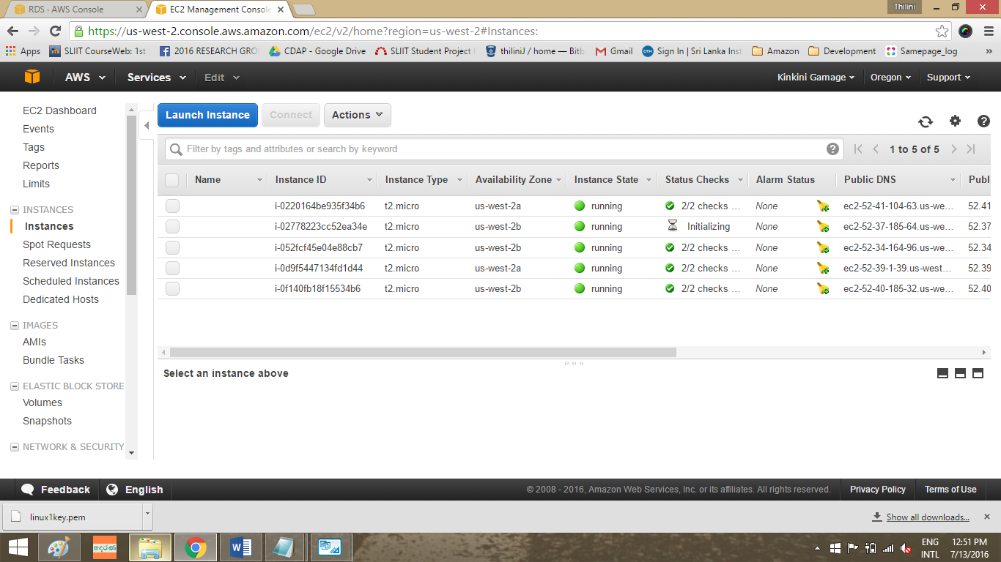Launch the instances that you have been created. On the Instances screen, you can view the status of the launch. It takes a short time for an instance to launch. When you launch an instance, its initial state is pending. After the instance starts, its state changes to running and it receives a public DNS name.
* Display the launch status.

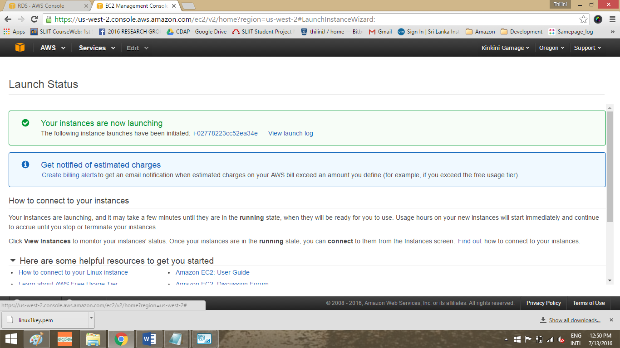

* Connect to Your Instance

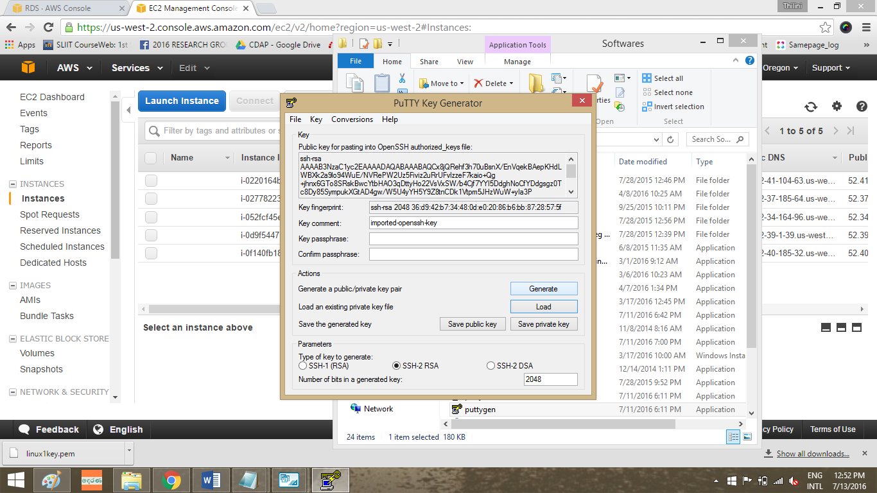There are several ways to connect to a Linux instance. For example connect with broser or connect using PuTTY or an SSH client. Here I have use PuTTY for connect with the linux instance.

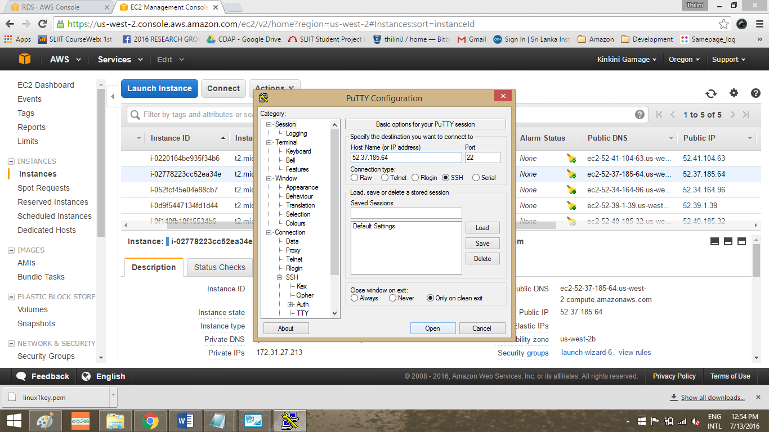

* 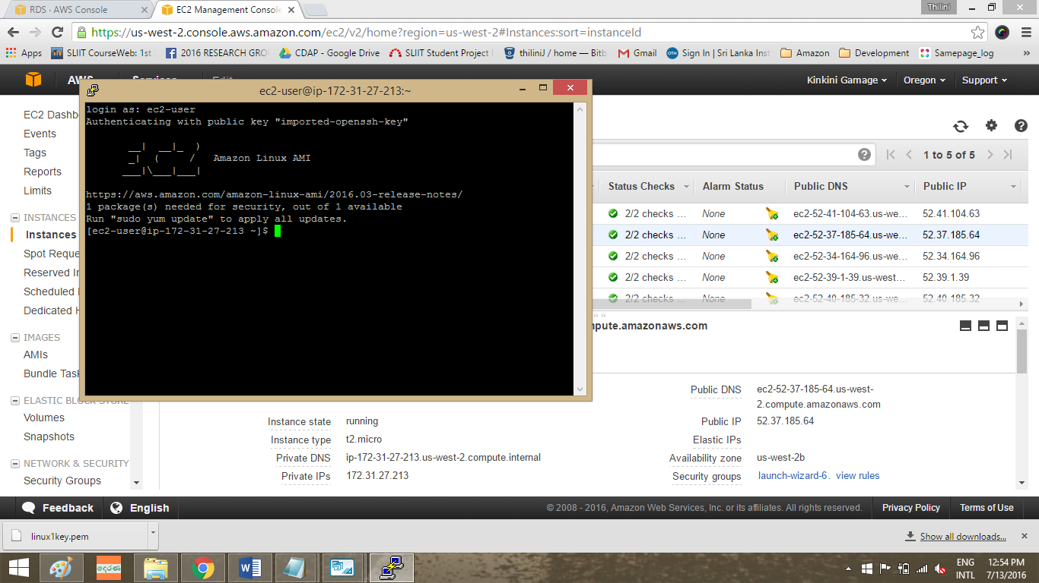Connected to the linux instance.
* To clean up the instance. After the instance is terminated, it remains visible on the console for a short while, and then the entry is deleted.

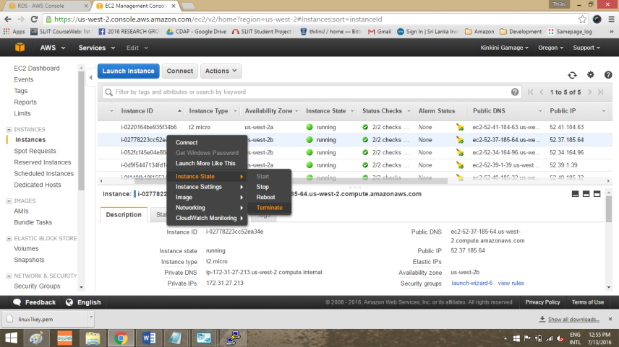

* The instance has terminated.

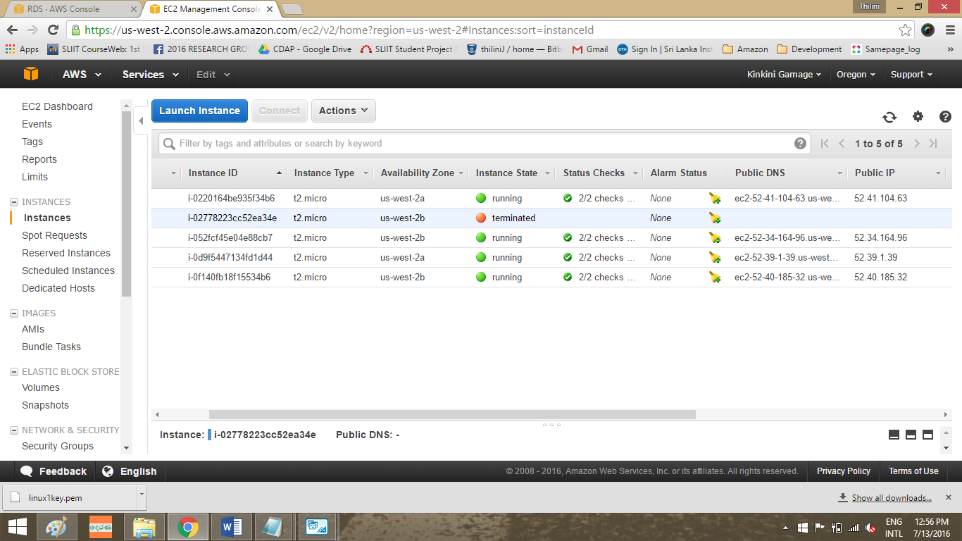

**Create an Amazon RDS Database**

Amazon Relational Database Service (Amazon RDS) is a web service that makes it easy to set up, operate, and scale a relational database in the cloud. You can migrate existing applications and tools that utilize a relational database to the Amazon Web Services because Amazon RDS offers access to the capabilities of a MySQL, Oracle, SQL Server, and the PostgreSQL database engine. Amazon RDS provides cost-efficient and resizable capacity while managing time-consuming database administration tasks.

* 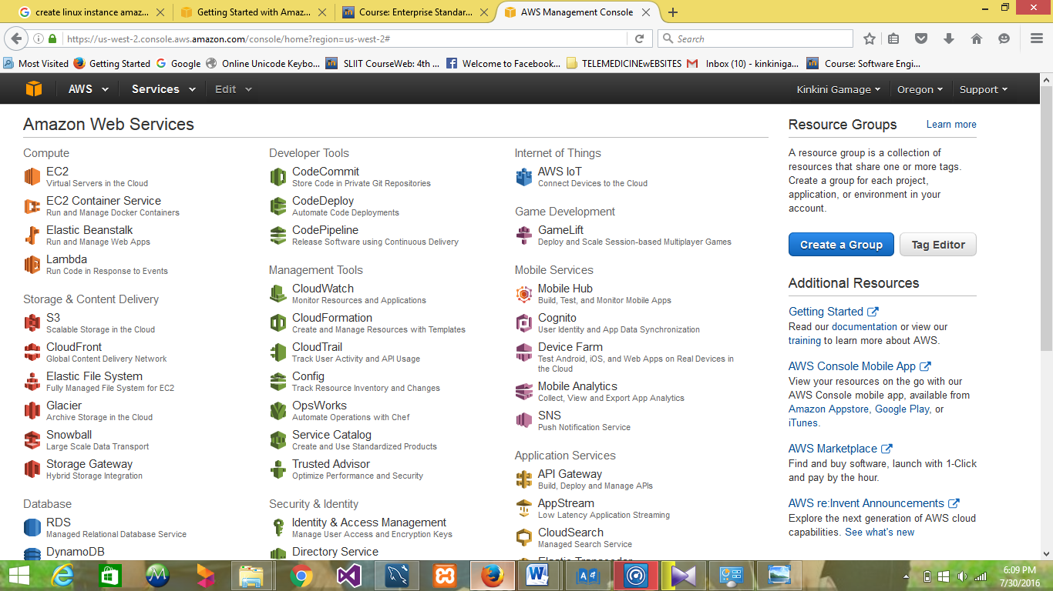Sign in to the AWS Management Console and open the Amazon RDS console

* 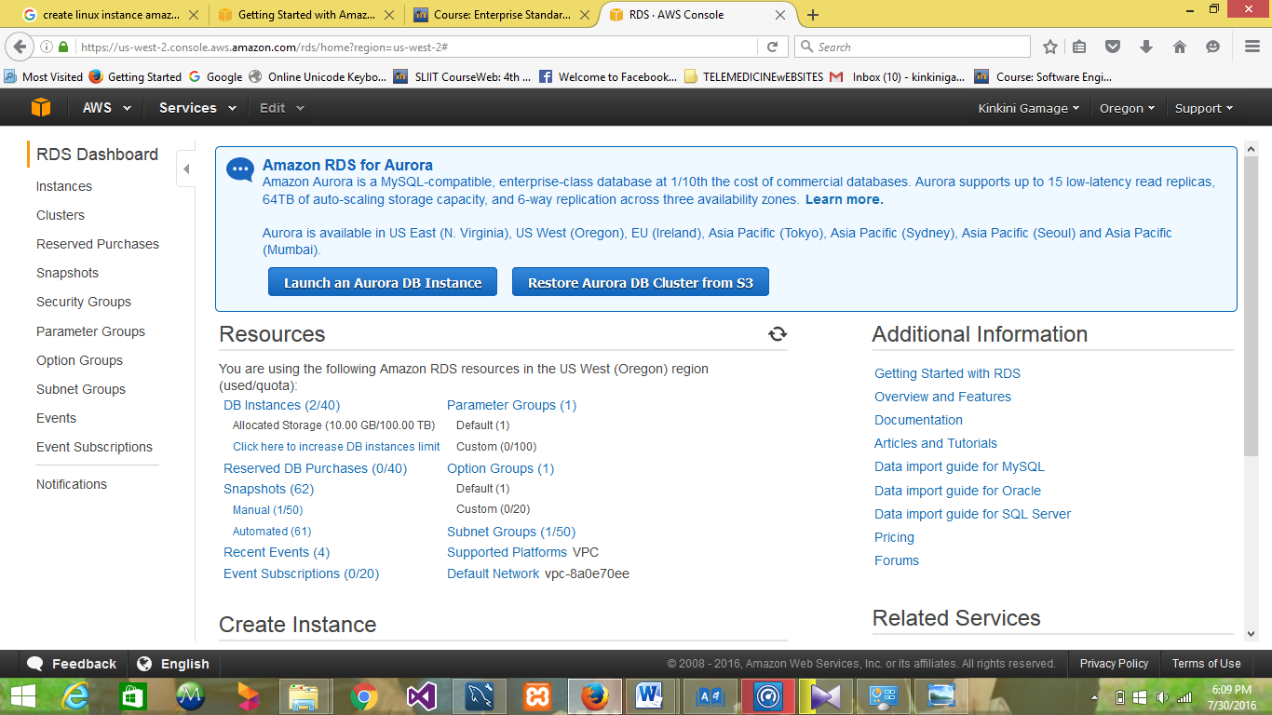Choose the region in which you want to create the DB instance and choose the Instances.

* Choose Launch DB Instance. The Launch DB Instance Wizard opens on the Select Engine page.

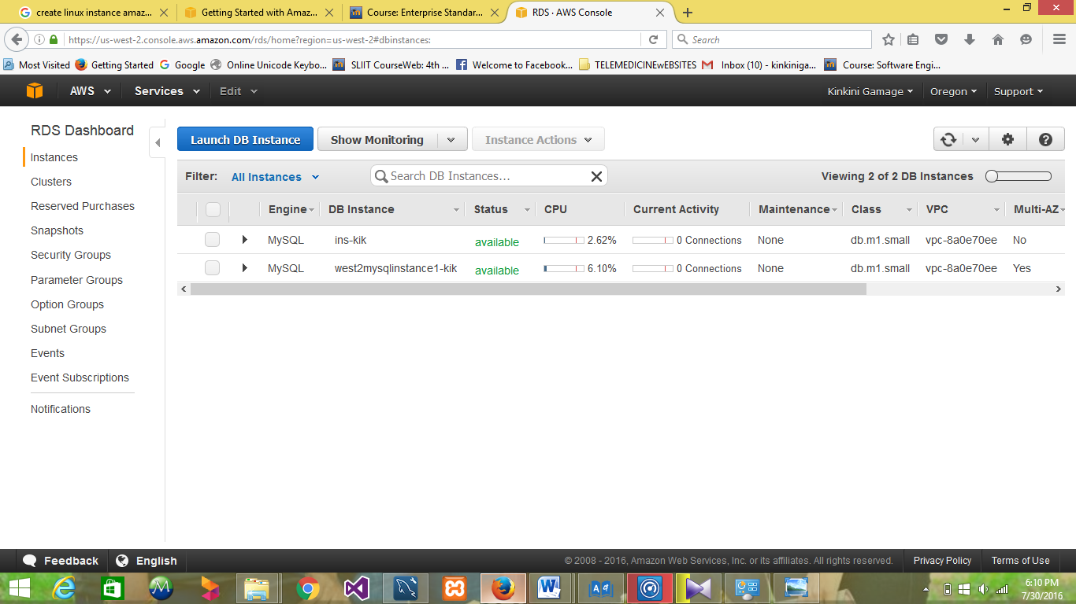

* Select MySQL DB engine. Choose MySQL database. This instance is intend for use outside of the production or under the RDS free usage tier

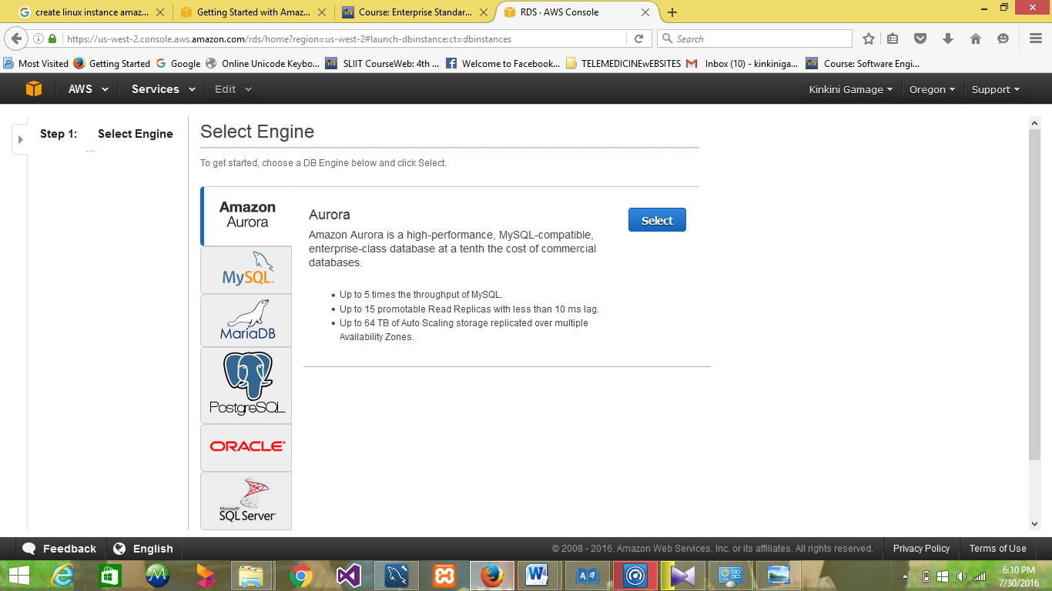

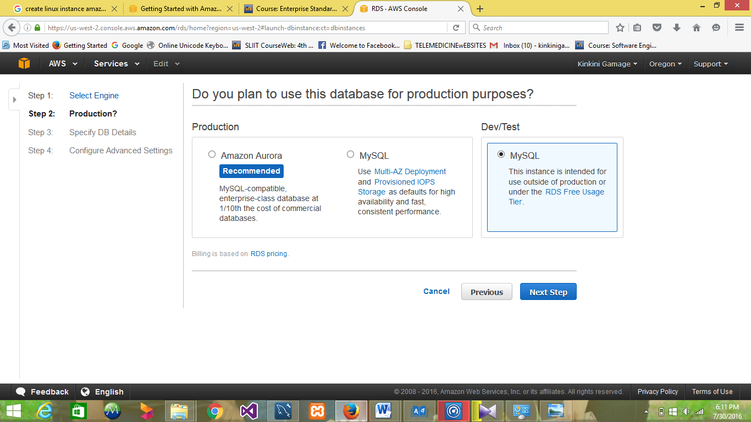

* Specify your DB instance information. The Amazon RDS Free Tier provides a single db.t2.micro instance as well as up to 20 GB of storage, allowing new AWS customers to gain hands-on experience with Amazon RDS.

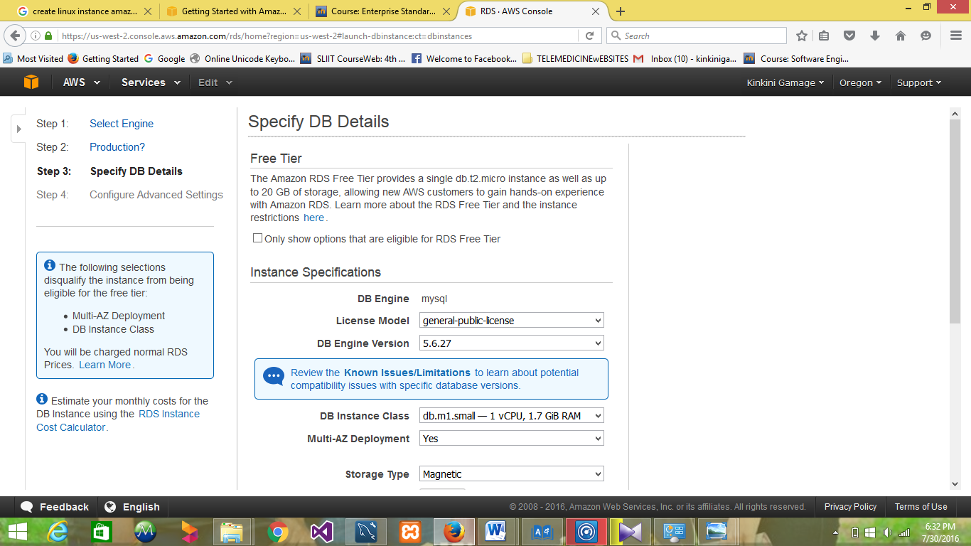

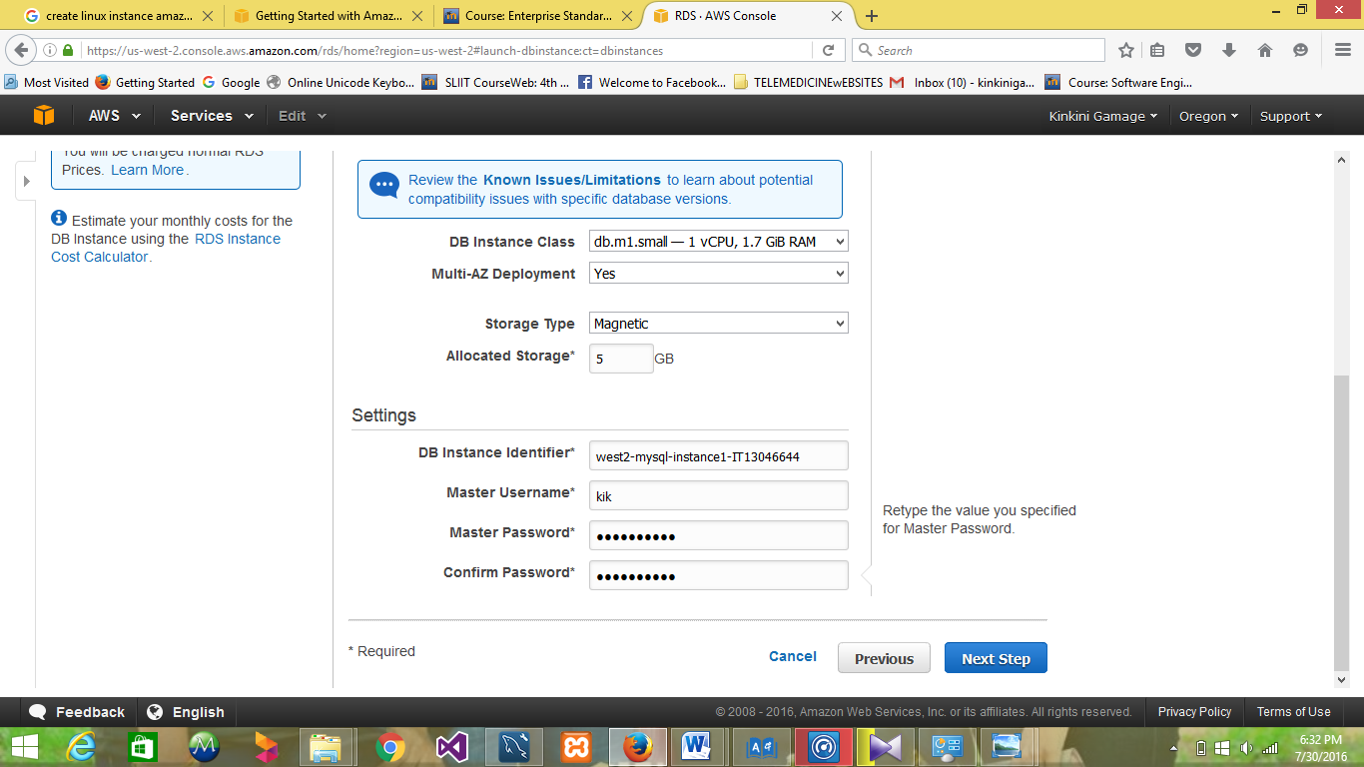

* Provide additional information that RDS needs to launch the MySQL DB instance. If no database name is specified then no initial MySQL database will be created on the DB Instance. The automated backups are currently supported for InnoDB storage engine only.

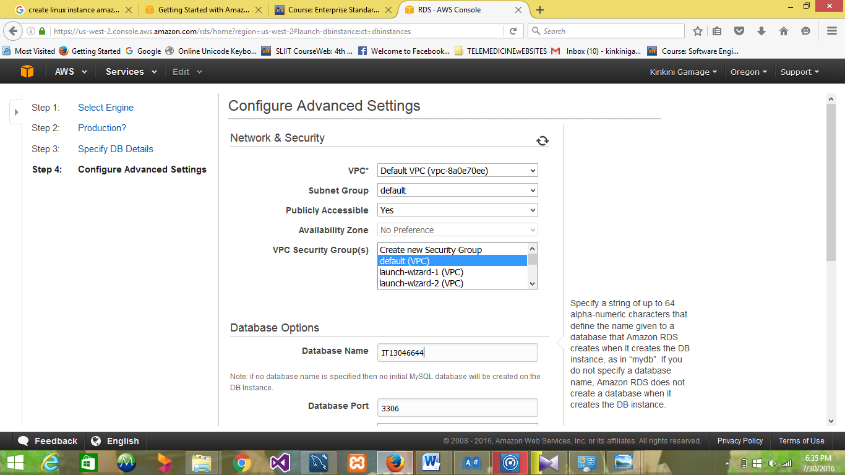

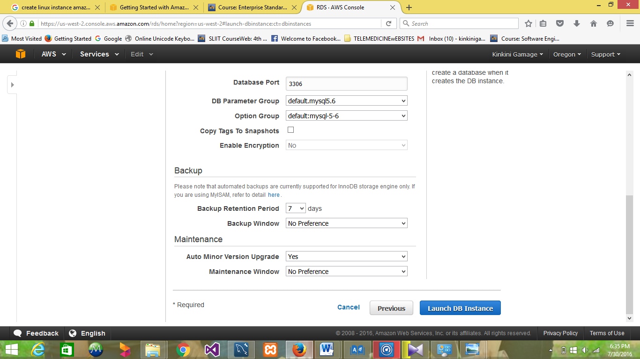

* On the RDS console, the new DB instance appears in the list of DB instances. The DB instance will have a status of creating until the DB instance is created and ready for use. When the state changes to available, you can connect to a database on the DB instance. Depending on the DB instance class and store allocated, it could take several minutes for the new DB instance to become available.

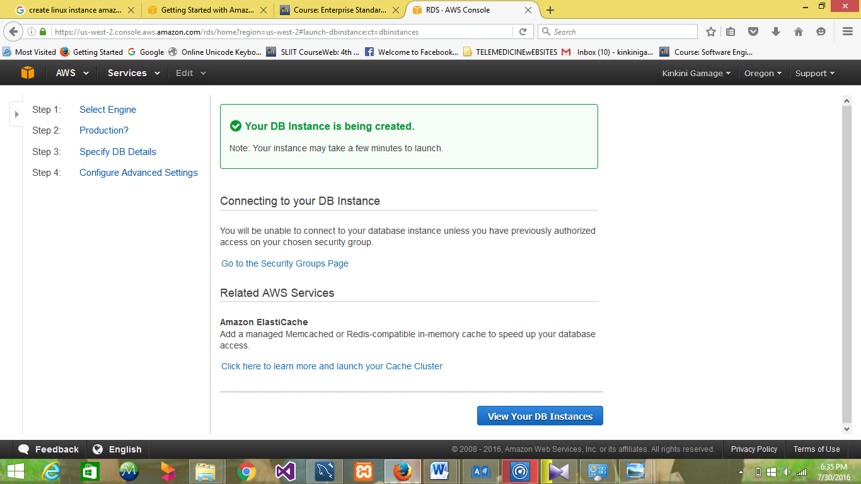

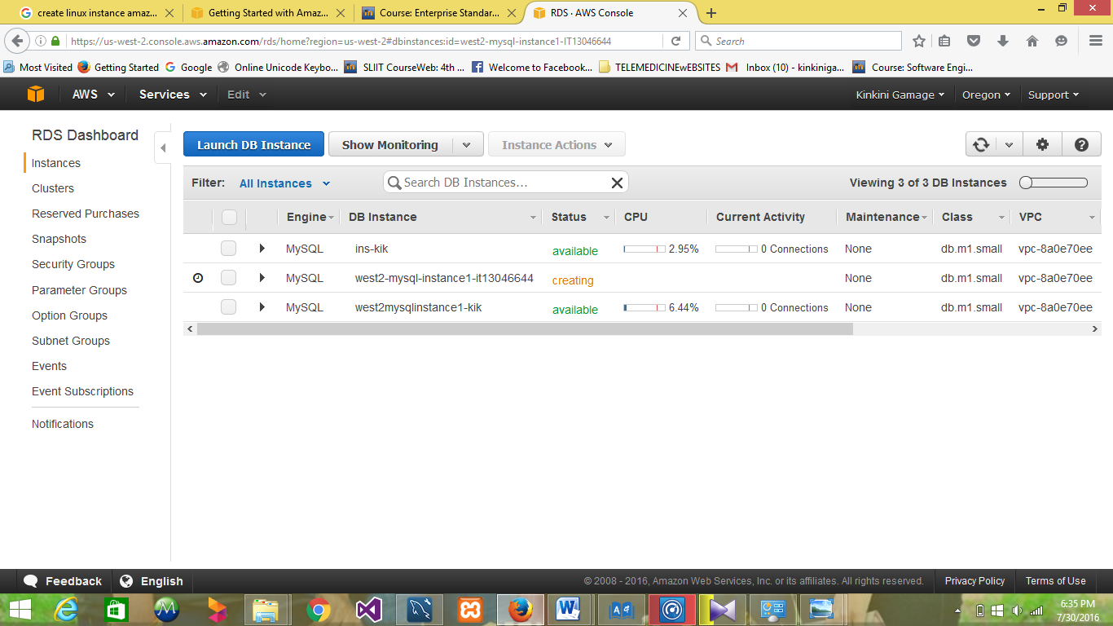

* Connect with DB instance.

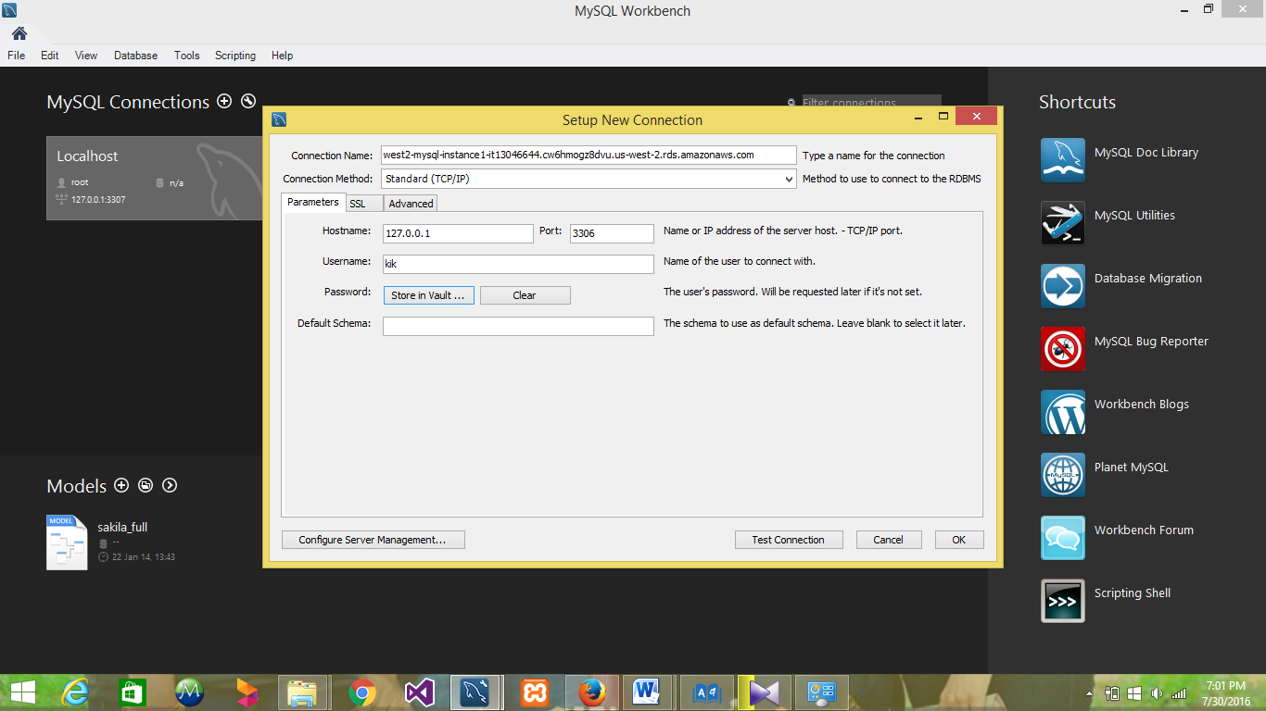

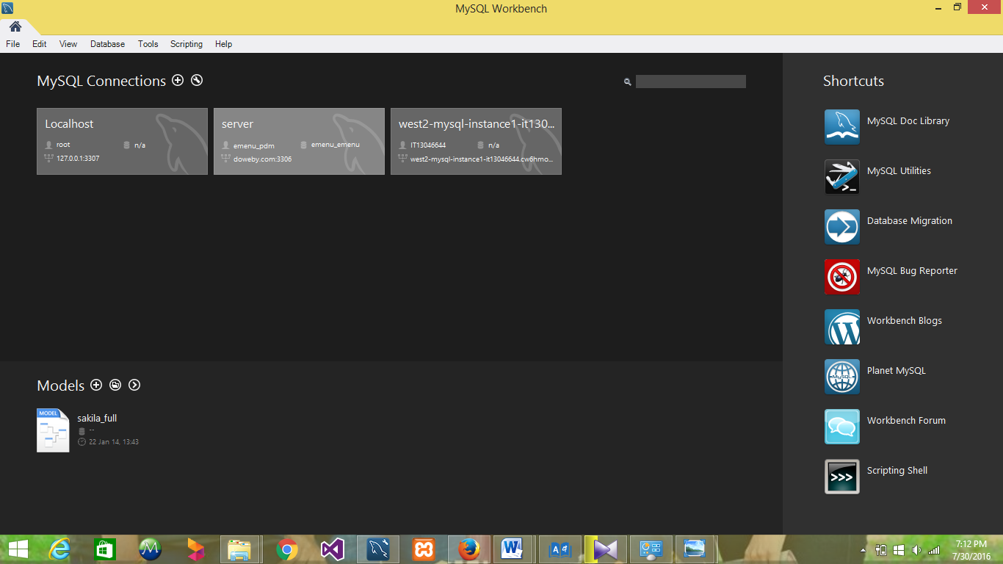

* To delete a DB instance with no final DB snapshot. Once you have connected to the sample DB instance that you created, you should delete the DB instance so you are no longer charged for it.

